**University Research Ethics**

**APPLICATION REFERENCE:**

**for office use only**

**Committee**

**Application Form**

**Checklist**

|  |  |
| --- | --- |
| **Name of applicant: Andrew Wicks** | |
| **Faculty/Directorate: ACH/CIS** | |
| **Title of research: Content factors which influence the success of a VLE. – Part 2** | |
| **These papers must be attached to this application form (please tick):** | |
| * Participant information sheet | ✓ |
| * Participant consent form | ✓ |
| **These papers may be required (tick if included):** | |
| * Letters (to participants, parents/guardians, participating institutions etc.) |  |
| * Questionnaire(s) or indicative questions for interviews | ✓ |
| * Advertisement /flyer/copy of message inviting participation | ✓ |
| * [Annex I](http://www.gre.ac.uk/__data/assets/word_doc/0009/644859/UREC-application-form-annex-1.doc) - Drugs and medical devices |  |
| * [Annex II](http://www.gre.ac.uk/__data/assets/word_doc/0010/644860/UREC-application-form-annex-2.doc) - Research involving the storage of human tissue |  |
| * [Annex III](http://www.gre.ac.uk/__data/assets/word_doc/0011/644861/UREC-application-form-annex-3.doc) - Ionising radiation |  |

**Has the form been signed? YES / NO**

**Have any annexes been signed where necessary? YES / NO**

Revised October 2015

### **SECTION 1: APPLICANT DETAILS**

|  |
| --- |
| * 1. Surname Wicks Forename Andrew Title Mr. |
| Faculty/Directorate: ACH/CIS |
| University address, including Faculty Department  University of Greenwich, ACH/CIS, Room QM420, Old Royal Naval College, 30 Park Row, London SE10 9LS |
| University Tel.: 020 8331 8717 E-mail: wa02@gre.ac.uk |
| * 1. Are you a student?   A member of staff?  A member of staff applying as a student? **Yes**  Other? |
| Programme of study (if applicable)  **MPhil/PhD** / EdD / Masters by Research / MSc / MA / BSc / BA / DipHE / other (please specify) |
| If you are a higher degree student, has your research project been approved by your Faculty Research Degrees Committee? Indicate YES or NO. **YES** |
| If YES, when? **10th Jun 2015** What is the FRDC reference number? **FRDCACH/14/M-5/4.5**  If NO, why not? |
| * 1. What is the primary purpose of the research? (Please indicate YES or NO) * Educational qualification **YES** * Internally funded research **YES**      * Externally funded research (please provide details of funding)      * Other (please specify)………………………………………………………………............................ |
| * 1. Project supervision – give the name of the research supervisor(s) and their contact information * Prof. Liz Bacon, University of Greenwich, QM353, Old Royal Naval College, 30 Park Row, London SE10 9LS (email: [e.bacon@gre.ac.uk](mailto:e.bacon@gre.ac.uk), Ext: 8544) * Prof. Lachlan MacKinnon, University of Greenwich, QM353, Old Royal Naval College, 30 Park Row, London SE10 9LS (email: [l.mackinnon@gre.ac.uk](mailto:l.mackinnon@gre.ac.uk), Ext: 8559) * Dr. Cos Ierotheou, University of Greenwich, QM334, Old Royal Naval College, 30 Park Row, London SE10 9LS (email: [c.ierotheou@greenwich.ac.uk](mailto:c.ierotheou@greenwich.ac.uk), Ext: 8655) |
| **1.5**Details of any other co-researchers within the university  None |
| * 1. Details of any other co-researchers external to the university   None |
| **1.8** Membership of professional bodies - are you or any co-researcher(s) a member of any professional, or other, bodies which set (i.e. require compliance with) ethical standards of behaviour or practice such as the British Psychological Society, Nursing and Midwifery Council, medical Royal Colleges etc.? If so, please specify.  **None** |

### **SECTION 2: PROJECT DETAILS**

|  |
| --- |
| * 1. What are the principal research questions posed by this research? Describe briefly, in lay terms, the proposed research project including step by step methodology, and its potential outcomes and benefits (no more than 250 words).   **Research question**: Which design features of a VLE affect its usability and effectiveness?  **Potential outcomes**: The first stage of the research, calculating the learning dissonance (please see the other ethical approval form submitted). This will assess the overall effectiveness – or lack of it – of on-line learning materials in general. The second stage will seek to assess the effectiveness of each of the learning elements by comparing the number of attempts in the end of task quizzes as well as the overall score by each student in the end of course assessment. The number of times each student uses one of the learning elements will also be monitored  **Potential benefits**: This study seeks to address the ad hoc nature of the design of on-line learning environments by assessing a range of literature-driven tools. If successful, then a more targeted learning environment could be produced which would be expected to raise attainment.  **Methodology**: A web site (a VLE plus learning management system) will be created. This will test the usage of the 20 learning elements inferred from a literature review.  The course learning materials will be broken into small tasks, each of which covers one and only one item in the syllabus. The on-line tasks are then broken into the 20 learning elements.  Some elements, such as the learning material itself and the title, will be included on all the pages, whilst others will be omitted according to a pre-determined binary pattern. The relative effectiveness of each item can then assessed by the mini-tests included and the summative marking at the end of the course. |
| **2.2** Are any of the following involved? (Please indicate YES or NO)   * Intrusive procedure e.g. questionnaire, interview, focus group, diary **YES**   (attach a copy of your questionnaire or indicative questions) **Please see Appendix A**   * Invasive procedure e.g. venepuncture, tissue sampling **NO** * Physical contact **NO** * Covert observation or covert filming / recording **YES** – their use of the VLE will be tracked. * Children / young people (under 18) – please include age of participants **NO** * Vulnerable people (elderly, physically or mentally ill, people with learning difficulties, in care, bereaved, prisoners, other) **NO** * Drugs, medicinal products or medical devices (if YES, complete [Annex I](http://www.gre.ac.uk/__data/assets/word_doc/0009/644859/UREC-application-form-annex-1.doc)) **NO** |
| **2.3** Has there been a pilot study for this research? (If YES, please give details)  No, but there have been pre-PhD attempts which focussed thinking (<http://www.edulevel.com> and then more recently <http://www.o-vl.com>). |

|  |
| --- |
| **2.4** What is the proposed start date (i) of the project and (ii) of the fieldwork (if different)?  **Start Date**: September 2017.  What is the proposed **end date** (i) of the project and (ii) of the fieldwork (if different)?  The end dates would depend upon the date of submission of the dissertation. Currently, this is expected to be 2018/19. |

### **SECTION 3: PARTICIPATION AND CONSENT**

|  |
| --- |
| **3.1** What are the selection criteria for the proposed participants in the study?  All students who are taking COMP1148 (Java Programming), COMP1430 (Systems Design and Development) and possibly COMP1556 (Database Management). |
| **3.2** How many participants are to take part?  Up to 450+ students per academic year, but an unknown proportion may prefer not to access the on-line materials. |
| **3.3** How will prospective participants be recruited / contacted and informed about their role in the project? (Give details and attach your participant information sheet, advertisement, email etc.)  Students will be made aware at the start of the course that these on-line learning materials are available as part of the course induction process, but that it is not compulsory to use them. These are additional materials which would have been made available regardless of the research.  There will be an explanation on the opening page of the site which explains the nature of the research. Should students decide to continue then the registration process includes a section where they are asked to give their consent to their anonymised data being used. A reminder that data is being collected is shown on the login page each time they visit the site.  Please see Appendix B. |
| **3.4** Where will the interaction with participants take place? e.g. online, classroom, public facility, laboratory, office, home etc.  There will be online interaction, but also some tutors may choose to use the learning management section of the VLE with students face-to-face. |
| **3.5** Are any external bodies’ premises or resources to be used? Please indicate YES or NO and give details of permission sought.  **Yes**. Internal data security does not allow the use of databases held on the University servers. It will therefore be necessary to use an external host. It is proposed to use IXWebHosting, who have been running the database driven proto-VLEs listed in section 2.3 above for the last seven years without incident. |
| **3.6** What is the expected total duration of participation in the study for each participant? e.g. 20 minutes to complete a questionnaire, an hour for an interview, etc.  That will depend on the usefulness (or otherwise) to the student. Some may not want to use the extra materials on offer, whilst others may use it constantly. It will be up to the student to decide. |
| **3.7** Is consent to be obtained using the UREC consent template? (Please indicate YES or NO and attach your [consent form](http://www.gre.ac.uk/__data/assets/word_doc/0003/644862/UREC-Consent-Form-final.doc)). If NO please indicate how consent is to be obtained, and attach a copy.  **No**. Consent would be given by accepting the conditions of use outlined on both the opening page and the login page. This would happen electronically. Please see Appendix B. |
| **3.8** If children or young people (under 18) are involved, please say how consent will be sought, from both the children / young people and their parents, guardians or those acting *in loco parentis* (e.g. school).  **Not applicable** because these are materials aimed at undergraduate or post-graduate students. |
| **3.9** Will any payment, incentive or reimbursement of expenses be made? (Please indicate YES or NO and give details, including amount)  **No**. |

### **SECTION 4: ETHICAL CONSIDERATIONS**

|  |
| --- |
| **4.1** What do you consider are the main ethical issues and risks that may arise in this research? (Refer to the Guidance on Ethical Approval for Research, [point 3.1](http://www.gre.ac.uk/research/ethics/what-might-be-the-ethical-issues-and-risks-that-arise-in-my-research)). What steps will be taken to address each issue?  **Potentially sensitive or embarrassing data**: Lecturers will be able to give feedback to their students on their work so far. This data would not be released once the research has been completed. However, data by the randomly generated student number (please see the ethical approval application for learning dissonance) will be made available when that has been anonymised. The data collected would contain information on the number of quiz attempts, how long they spent on a task, etc..  **Matters around the subject matter**: Only course materials are being presented.  **Matters around participants**: The participants would be my own students and some of my colleagues would also be assessing them. However, an identifying information would be removed before publication in the same way as for the learning dissonance statistic. Please see Appendix C for details of the layout of the data.  **Matters around the researcher**: There are no conflicts of interest for the researcher.  **Matters around the recruitment of participants**: Participation is entirely voluntary and students can dip in and out as they like. These are extra materials presenting an alternative learning strategy to those already being offered and these do not form part of the assessment process.  **The nature of the participants**: These are learning materials, so participants would not be disclosing any confidential information.  **Risks or hazards to participants or researchers**: There are no risks beyond those inherent in any learning environment.  **Location of participation**: There are no location related hazards associated with this study.  **Confidentiality issues**: Anonymity will be achieved by the use of random numbers used to identify individuals. The nature of the data being collected is unlikely to be seen as controversial. No personal information beyond that needed to verify the identity of the student will be collected.  **Other health and safety issues**: There are no other health and safety issues. |

|  |
| --- |
| **4.2** Will personal data, as defined by the Data Protection Act 1998, be collected during the research (Refer to the Guidance on Ethical Approval for Research, [point 3.2](http://www.gre.ac.uk/research/ethics/am-i-collecting-personal-data-in-research))? Indicate YES or NO. If YES, give details of how you will deal with that data. **YES**  **What personal information will be collected?**: Anonymity will be achieved by the use of random numbers used to identify individuals. The nature of the data being collected is unlikely to be seen as controversial (e.g. their usage statistics of the VLE). No personal information beyond that needed to verify the identity of the student will be collected.  **Gain consent for collecting and processing the data**: Consent would be given by accepting the conditions of use outlined on both the opening page and the login page. This would happen electronically. Please see Appendix B.  The data made available after the study will be anonymised as explained in previous sections and is shown in Appendix C.  **Provide enough information about the project for the participant to be able to give informed consent**: There will be an explanation on the opening page of the site which explains the nature of the research. Should students decide to continue then the registration process includes a section where they are asked to give their consent to the anonymised data being used. A reminder that data is being collected is shown on the login page each time they visit the site.  Please see Appendix B.  **Security of the data**: Internal data security does not allow the use of databases held on the University servers. It will therefore be necessary to use an external host. It is proposed to use IXWebHosting, who have been running the database driven proto-VLEs listed in section 2.3 above for the last seven years without incident.  **Retention of the data**: The anonymised data, as shown in Appendix C, will be made available via the University systems. Were the systems shown to be of benefit to the students then their login details would be retained so that they can continue using it. They would have to opt in for that or re-register later.  **Disposal of data**: The data for those who indicated that they did not want to be part of the study will be deleted at the end of their course. Those who say that they are willing to be part of the study, but do not want to opt in to continued registration will have their data login data deleted once the Ph.D. has been completed which is expected to be in 2018/19.  **Confidentiality of data**: The only possible identifying data for students are their enrolment number (which, when encrypted using MD5 becomes the student ID) and their email address, both which are needed to verify that they are enrolled on the course. The email address is also needed so that contact can be kept during the study. All data held externally is password protected at two levels and using a pass phrase rather than a password adds another layer of security.  **Ensure that data is published only in anonymised form**: Only the tables indicated in Appendix C as being made available will be published once the study is completed. As can be seen, this does not include any identifying information.  **Future use of data**: It ought to be possible to use the data to assess the attention span and usage modes of students, but this is not within the scope of this study. However, there would not be any need for identifying information, so these would use the openly published data. |

### **SECTION 5: INSURANCE AND FINANCIAL INTERESTS**

|  |
| --- |
| **5.1** Will this research be covered by an insurance policy (such as your own professional indemnity insurance) other than the University of Greenwich public liability policy? If so, give details.  **NO** |
| **5.2** Indicate by “YES” or by ticking one of the statements below:   * I declare there is no financial or other direct interest to me or my Faculty or Directorate arising from this study **YES** * I declare there is a financial or other direct interest to me or my Faculty or Directorate arising from this study (supply details) |

### **Signatures**

|  |
| --- |
| I undertake to carry out research in accordance with the University’s [Research Ethics Policy](http://www.gre.ac.uk/research/rec/rep). In the case of a higher degree, I confirm that approval has been given by the Faculty Research Degrees Committee. |
| **Signature of applicant Date**  **Print name** |
| I have discussed the project with the applicant, I confirm that all participants are suitably qualified to undertake this research and I approve it.  **Signature of supervisor (to be signed if applicant is a student) Date**  **Print name** |
| I have reviewed the project with the applicant, or applicant’s supervisor, and I confirm that all participants are suitably qualified to undertake this research and I approve it.  **Signature of** [**UREC representative**](http://www.gre.ac.uk/research/rec/faculty-representatives) **Date**  **Print name** |

### Appendix A – The Follow-up Questionnaire

Students will use the site as they see fit. Their usage statistics will be gathered by the system and therefore this will therefore be a matter of recorded fact. However, a comparison between these facts and the student perception of the facts would shed light on the perceived motivational effect of the different learning elements. It is this perception that these questions are designed to cover.

|  |  |  |  |
| --- | --- | --- | --- |
| **Learn. Item No.** | **Item** | **Questions** | **Analysis** |
|  | Each task page | How often is it hit by each student?  How long is each visit? | Bar chart and averages.  Mean and standard deviation. |
|  | Student office | How often is it hit by each student? | Bar chart and averages. |
| How long is each visit? | Mean and standard deviation. |
|  |  |  |  |
| 1 | Title | Not applicable |  |
| 2 | Summary (1) | Does this affect the speed at which a task is completed? | Difference between mean time to complete and certify for those tasks using this against not using it. |
| Does this affect the completion rate? | Difference between completion rates for those tasks using this against not using it. |
| 3 | Internal links | Not applicable |  |
| 4 | Useful sites | Not applicable |  |
| 5 | Contents | Not applicable |  |
| 6 | Alternative contents (2) | Does this affect the speed at which a task is completed? | Difference between mean time to complete and certify for those tasks using this against not using it. |
| Does this affect the completion rate? | Difference between completion rates for those tasks using this against not using it. |
| 7 | Associated materials | Not applicable |  |
| 8 | Reliesons (3) | Does this affect the speed at which a task is completed? | Difference between mean time to complete and certify for those tasks using this against not using it. |
| Does this affect the completion rate? | Difference between completion rates for those tasks using this against not using it. |
| 9 | External links (4) | Does this affect the speed at which a task is completed? | Difference between mean time to complete and certify for those tasks using this against not using it. |
| Does this affect the completion rate? | Difference between completion rates for those tasks using this against not using it. |
| 10 | Quiz (5) | Does this affect the speed at which a task is completed? | Difference between mean time to complete and certify for those tasks using this against not using it. |
| 11 | Quiz results (5) | Does this affect the completion rate? | Difference between completion rates for those tasks using this against not using it. |
| 12 | Student generated content (6) | Does this affect the speed at which a task is completed? | Difference between mean time to complete and certify for those tasks using this against not using it. |
| Does this affect the completion rate? | Difference between completion rates for those tasks using this against not using it. |
| 13 | Approval rating | Not applicable |  |
| 14 | Feedback | Not applicable |  |
| 15 | Social media links (7) | Does this affect the speed at which a task is completed? | Difference between mean time to complete and certify for those tasks using this against not using it. |
| Does this affect the completion rate? | Difference between completion rates for those tasks using this against not using it. |
| 16 | Tasks set | Not applicable |  |
| 17 | Additional coursework materials | Not applicable |  |
| 18 | Task feedback | Not applicable |  |
| 19 | Usage statistics | Not applicable |  |

**The Questionnaire**

This would be in two parts. First, it would helpful to know their views on this asynchronous method of learning. Second, their views on the items being assessed would be sought. Many of the questions would involve semantic differential answers, where the respondent chooses their position on a scale. These are denoted by SD*n* (where *n* is the number of gradations, e.g. SD5 would be a five step scale).

The questions in the first section might be:-

* How easy was the system to understand when you first started? (SD5 from easy to hard)
* How long did it take you to complete the first task after (i.e. 100% on the quiz or signed off by the tutor) starting? (less than ¼ hour, less than ½ hour, less than 1 hour, by the end of the first lab session, within the first teaching week, within the first two weeks of teaching, within the first month of teaching, after the first month)
* Once you started an academic task, how long did it usually take you to complete it? (i.e. 100% on the quiz or signed off by the tutor) (15 minutes, 30 minutes, an hour, two hours, a day, a week or longer)
* Did you complete the tasks in order? (yes, no)
* Which was the easiest task? (list of tasks)
* Which was the hardest task? (list of tasks)
* Did you access all the tasks? (yes, no)
* Did you complete all the tasks? (i.e. 100% on the quiz or signed off by the tutor)
* How useful did you find this method of learning? (SD10 from very helpful to useless)
* Which method of learning do you prefer? (from chalk and talk, chalk and practical exercises, chalk and these materials, practical and these materials and a tutor, these materials and a tutor or just these materials)

The questions in the second section might be:-

* Did you read the summary of the task before starting? (SD5 from never to always)
* Sometimes a task had a summary and sometimes it did not. How much did you miss them when they were missing? (SD5 from a lot to not at all)
* Did you use the links video, MP3 or PDF when working on a task? (SD5 from never to always)
* Sometimes a task had links to video, MP3 or PDF and sometimes it did not. How much did you miss them when they were missing? (SD5 from a lot to not at all)
* Did you the links to materials which might help with whilst working on a task? (SD5 from never to always)
* Sometimes a task had links to materials which might help and sometimes it did not. How much did you miss them when they were missing? (SD5 from a lot to not at all)
* Did you use the links to alternative materials available on the web when working on a task? (SD5 from never to always)
* Sometimes a task had a summary and sometimes it did not. How much did you miss them when they were missing? (SD5 from a lot to not at all)
* Did you try the quizzes when working on a task? (SD5 from never to always)
* Sometimes a task had a quiz and sometimes it did not. How much did you miss them when they were missing? (SD5 from a lot to not at all)
* Did you look at the student generated content when working on a task? (SD5 from never to always)
* Did you create any student generated content when working on a task? (yes, no)
* Sometimes a task had student generated content and sometimes it did not. How much did you miss them when they were missing? (SD5 from a lot to not at all)
* Did you use the social media links when working on a task? (SD5 from never to always)
* Did you use the social media links for non-academic purposes when working on a task? (SD5 from never to always)
* Sometimes a task had social media links and sometimes it did not. How much did you miss them when they were missing? (SD5 from a lot to not at all)

Some of the answers to these questions can be calculated from the data gathered when the student uses the site. It will therefore be interesting to see how their perceptions match the data.

### Appendix B – Study description and permissions

The outline of the site is currently held at <http://www.comp1148.net>. There is no pass phrase protection there. This is merely a dummy site to try colours and layouts. No data is being recorded there.

The address for the real study will be different. Originally, it was intended to just use the course COMP1148 – Java Programming, but the materials for COMP1430 – Systems Design and Development are mostly there, so this could be used to assess the general effectiveness of this form of VLE. COMP1430 runs in semester 1 on level 7 courses, whilst COMP1148 runs in the second semester on level 4 courses. This would allow COMP1430 to be used as a test for the system in general, whilst COMP1148 would be the main target of the research. The course tutor for COMP1556 – Database Management, which runs in the second semester, is quite keen to trial the system too.

The next pages show the project description (the opening page of the web site) and the login form, which is used to obtain user consent. Each page is quite long, so they have been split into sections to make them easier to read.

**The opening page (**<http://www.comp1148.net>**)**

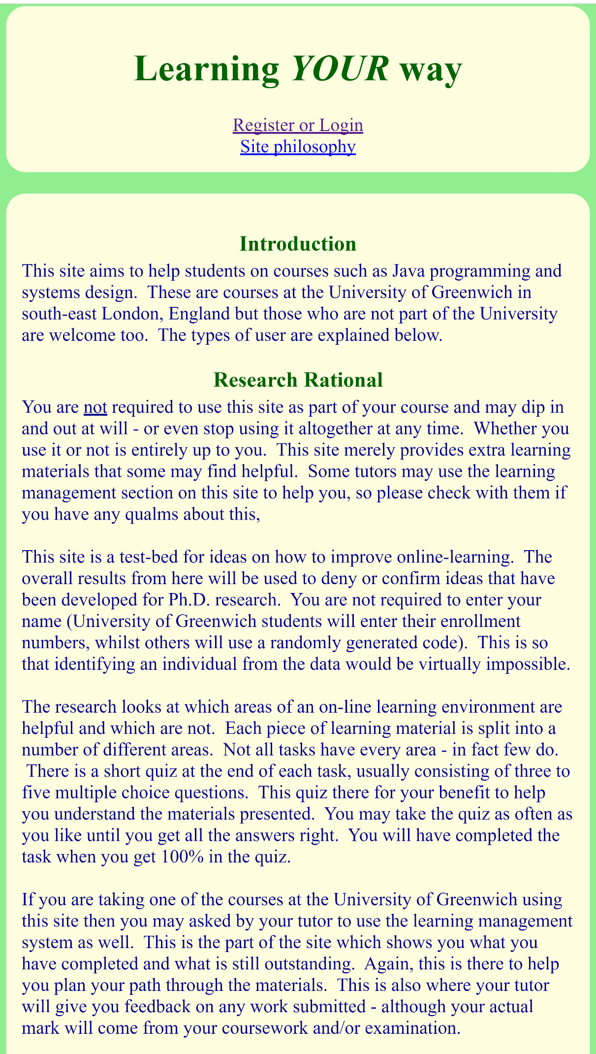

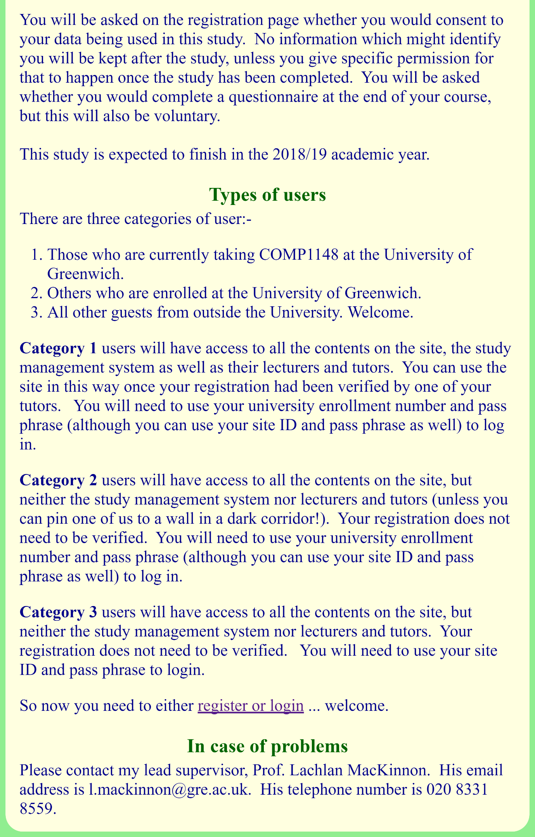

**The registration page (**<http://comp1148.net/register.php>**)**

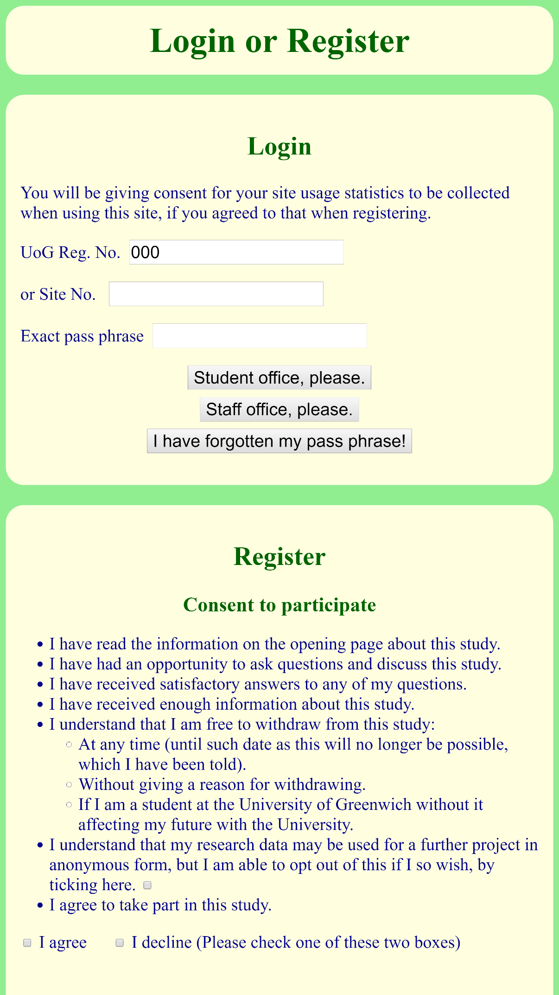

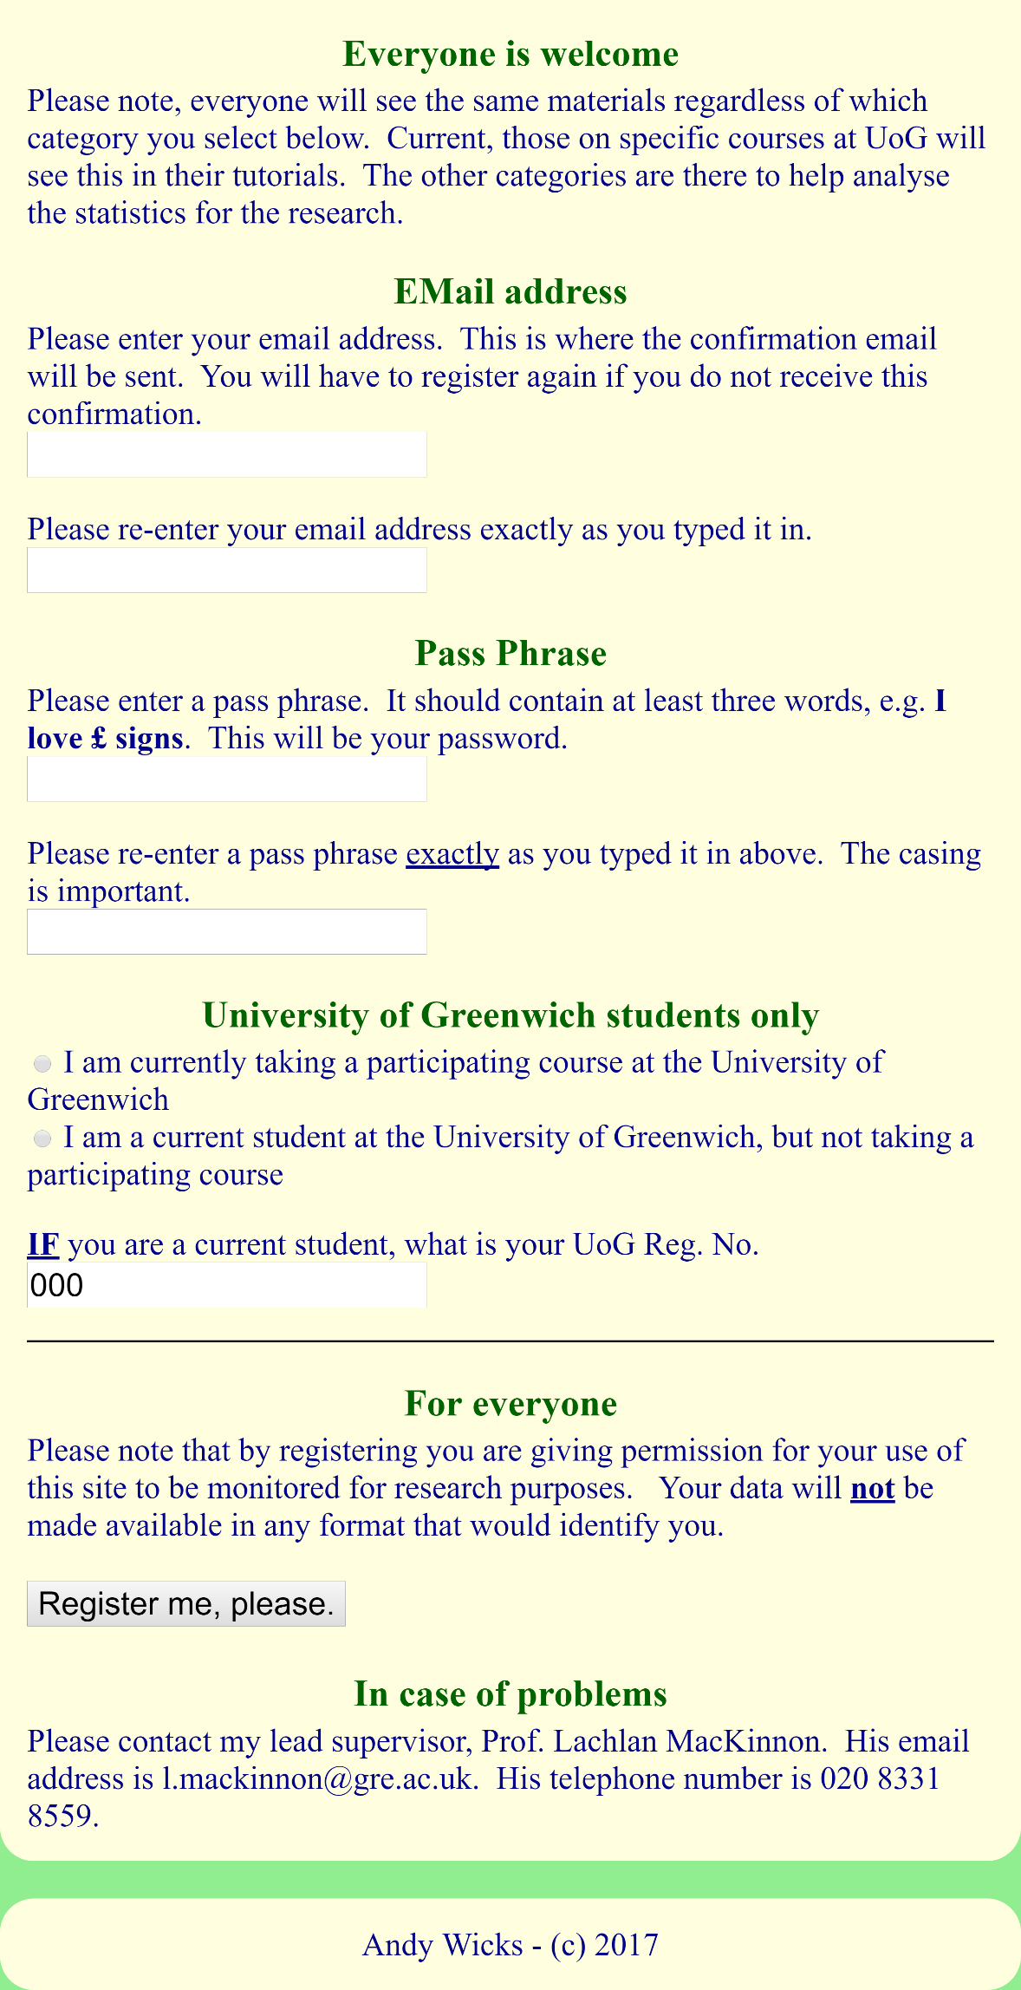

### Appendix C – Data Design

